5/13/2019

Manasbi Parajuli

Senior project

<https://github.com/manasbiparajuli/annapurna-racing>

ANNAPURNA RACING

Project Manual

**INTRODUCTION**

Annapurna Racing is a 3D single racing player game developed using the Unity Engine. The game consists of one racing track named Annapurna Circuit as well as three game modes called Default Race Mode, Score Mode and Time Mode. Also, there are three custom cars in the game where the player has the option to use two default cars (red and blue race cars) and a third car (green race car) that is initially locked. The locked car can be unlocked by using the cash earned by the player after completing races in Default Race Mode. The game is available only for Desktop PCs. I did not intend the game to be run in Android or iOS devices.

**Inspiration**

I have been playing racing games from a young age and have been very fond of them. I spent most of my best years playing racing games such as “The Need For Speed” series and “The Midtown Madness” series. The adrenaline rush of driving a car without any rules to abide by as I reached speeds of 155 mph are very motivating, or the objects that I can pass through to score as many points as possible within the lap limits is very exhilarating. Also, the selection of high-end cars from car brands such as Ferrari, Mustang, and Beetles added a new thrill to my racing experience.

As I progressed in my Computer Science courses in my college year, the idea of understanding more about my favorite game genre was very appealing. I wanted to understand the effort put into designing a game track and the process of enriching the game environment. Also, I wanted to experiment with the different versions of the AI algorithms implemented in racing games.

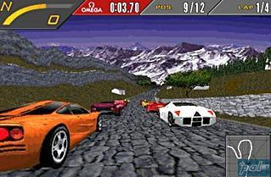

Figure A racing track located in Nepal in Need For Speed 98

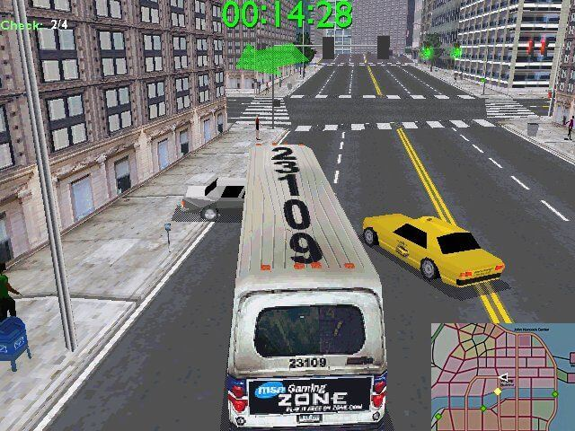

Figure A game scene in Midtown Madness

Usually, game development companies have different departments handling various aspects of the game. Developers have titles such as Level Designer, AI Programmer, and Sound Designer in the game industry. As a single developer, perfecting all these roles is exhausting and takes much exposure in different areas. However, I have tried my best to touch on all the aspects of the game to create an exciting racing experience for the player. There have been awkward moments such as creating the racetrack or selecting the sounds that best fits the game or implementing an AI system. Overall, the struggles of debugging the scripts or aligning the game objects to create a convincing racing game have been an enriching experience.

**Technologies/Sources Used**

I developed the Annapurna Racing game using the popular Unity Game engine. The engine handled all the game physics and the animations. I wrote scripts in the C# programming language to modify the game objects in the racing track. The scripts handled activating and deactivating various game objects as per the game modes. Also, scripts handled the skybox rotation and kept track of the lap times.



Figure Unity Technologies logo

I imported all the game assets from Unity Asset Store which were all free to use. The skybox assets that are used in the background of the game scenes or the mountains and trees used to enrich the game environment of the track were all free.

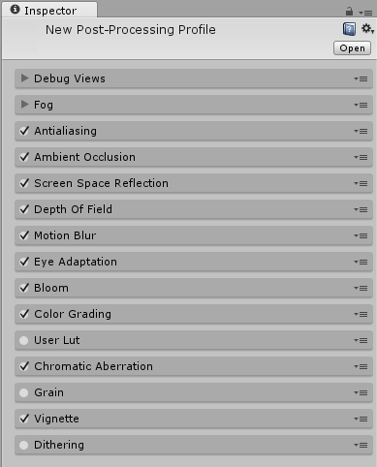

Figure The various properties in Unity's Post Processing Stack used to enhance graphics

The audio files used throughout the game were all free to use and downloaded from freesound.org website. Additionally, to enhance the graphics of the game, I imported Unity’s Post-Processing Stack into the game scene to customize graphics properties such as anti-aliasing, bloom, color grading, depth of field, motion blur and vignette and make the game visually appealing.

**Installation Instructions**

Annapurna Racing is available only for Desktop PCs. I may plan to integrate features in future versions to bring it to mobile devices. The game was developed using Unity version 2019.1.0f2 (64-bit). The entire source code for the game can be found at <https://github.com/manasbiparajuli/annapurna-racing>. The game can be run directly by executing the “Annapurna Racing.exe” file after which a short dialog box appears with options to play the game either windowed or full screen, screen resolution, graphics quality (very low, low, medium, high, very high and ultra). Hence, the game is technically easy to follow around.

If the project has been downloaded from GitHub, then the project needs to be run using Unity. To run the game, go to File-> Build and Run. Then, you will see an application dialog to run the executable file of the game. You may need to install some packages required by the project which will be handled by the Editor itself and installation of “PC, Mac & Linux Standalone” is required in build settings.

**User’s Manual**

**Racetrack: Annapurna Circuit**

**Introduction**

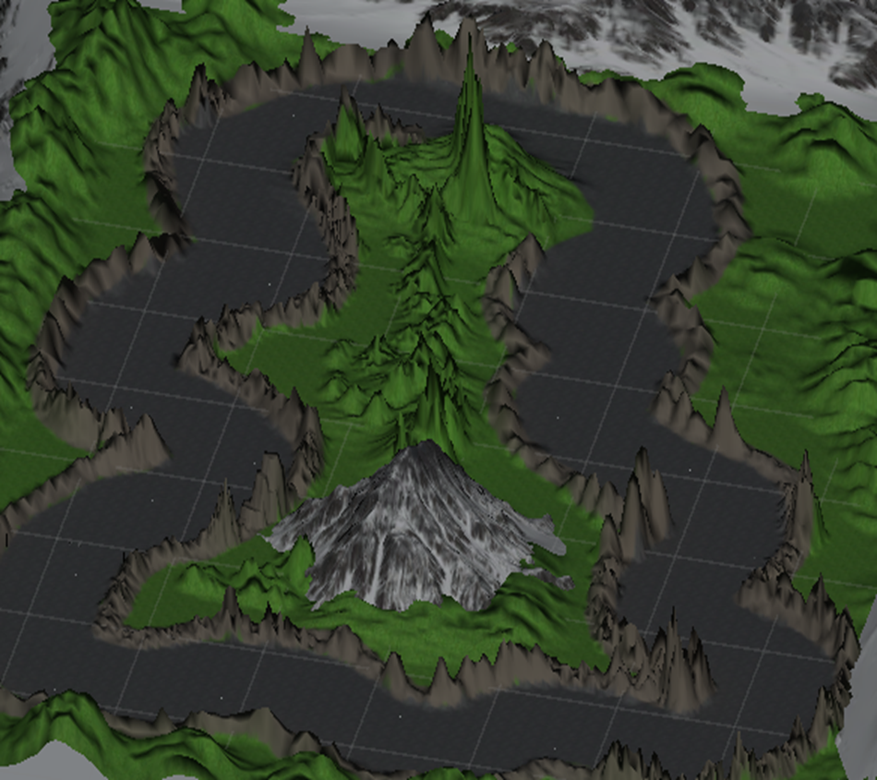

Figure The Annapurna Racing Track

Annapurna Racing consists of just a single track. Initially, the racing track is designed using the terrain system in Unity. The terrain system contains brushes whose style and sizes can be customized to raise the terrain. I raised majority areas of the terrain to create hills around the track. Race cars cannot pass through the hills to discourage cheating from the players such as traversing across the track diagonally. I used three different terrain textures to create the effect of asphalt roads, the banks of the racing track and the mountain areas.

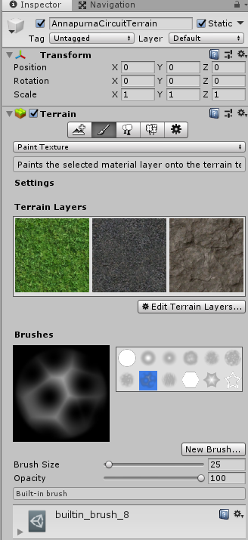

Figure The three different terrain layers used in the racing track. They are grass, asphalt, and rock layers.

Leveling only certain areas of the track was the most time consuming of the entire project. The attention to details in creating hills around the racetrack while maintaining the plain level track was exhausting and enjoyable at the same time. I never had any prior experience at working with the terrain system. Hence, I had to be cautious to ensure that the cars were able to race freely around the track without any bumps in them.

Once the terrain system had been modified, I imported mountains assets from Unity Asset Store and placed them along the edges of the terrain and one in the middle of the terrain. I also imported varieties of trees and bushes to spread across the hills that aided in enriching the game environment.

The entire process of level design has increased my appreciation for the level designers in the game industries. The level designers put attention to small details into designing various levels with different difficulties and hence appeal to the mass game users.

**Track Colliders**

A racing track needs to ensure that players can only stay on the track and not race through the terrains. We do not want players to take shortcuts to win the race illegally. For my game, I placed a lot of game objects around the racing track that had colliders attached to them. I used cuboid game objects for straight parts of the track while cylinder game objects are placed along the curves of the track.

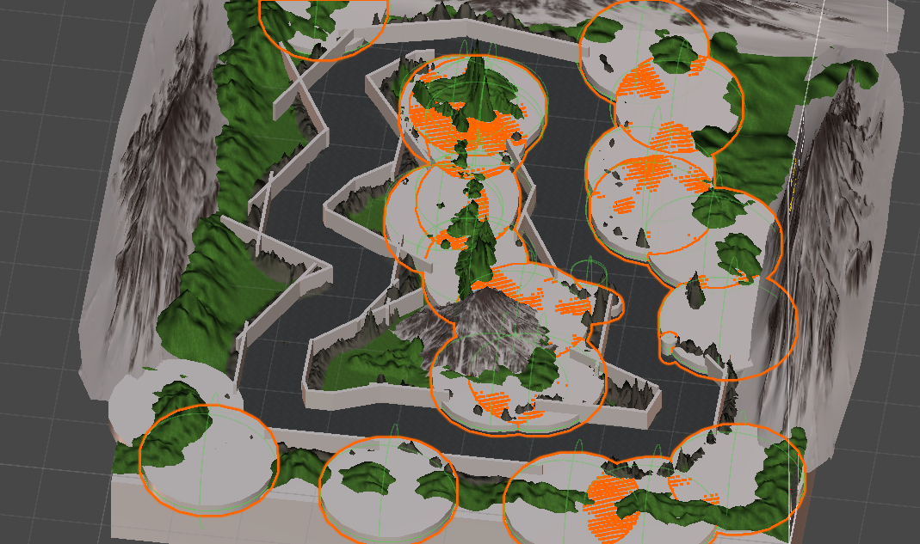

Figure The racetrack with colliders. Many cuboids and cylindrical game objects have been placed to discourage cheating from the racers

The game objects are placed on both sides of the banks of the racing track. The colliders in these game objects do not let the cars pass through the terrain. The box colliders present in these objects are adjusted to make the cars collide smoothly especially where two game objects intersect.

**Race Cars**

I used Unity’s Standard Assets Car Pack for AI and player’s cars. It had all the scripts that handled the physics behind the car engine and the car wheels. Additionally, the pack contained Car Audio that synchronized with the car engines or the smoke effects when the car moves around the track. These readymade scripts allowed me to focus on other aspects of the game and pack the game with more features.

For the player cars, I created different colored textures that are attached to the bodies of the cars for a different flavored race. Initially, all the colored cars are disabled, and the player has the option to choose between the available cars based on their preferences.

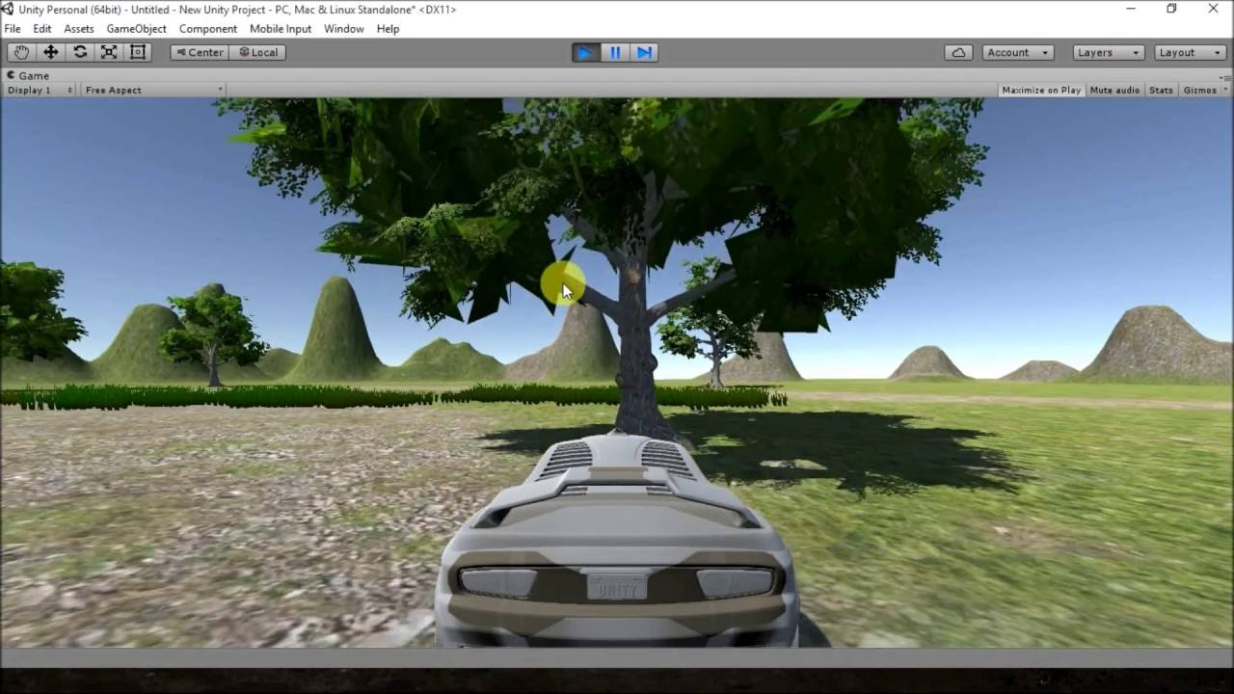

Figure The car pack imported from Unity's Standard Assets. I created different colored cars by attaching colored textures into the car body

**AI Waypoints and AI Car Algorithm**

For the AI cars, I have put many waypoints around the track. Unity’s Standard Assets Car Pack contains a script that moves the AI car around the track if we attach a game object containing a list of waypoints.

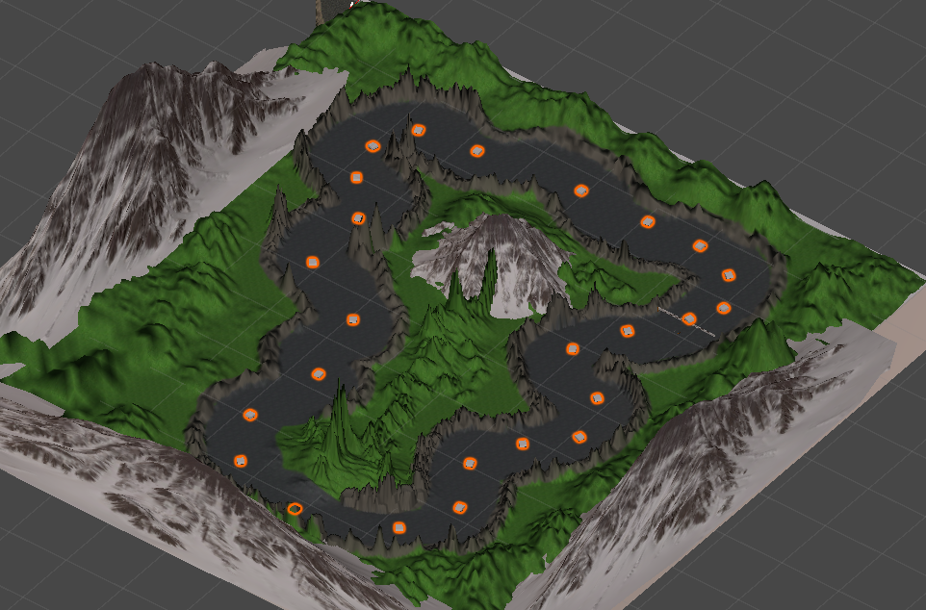

Figure The AI waypoints that I set up in the track. All of the waypoints are nester under Tracker game object in my Unity project window

The AI Waypoints algorithm updates the position of the race car by selecting the next waypoint in the track. The waypoints have colliders attached to them which act as the pivot for the AI Waypoint script to point to. The AI Cars pass through these pivots and then proceed to the next one.

The following code updates the position of the AI car to point it to the next waypoint.

**Void Update()**

**{**

**// move the AI car’s position to the next waypoint in the track**

**Tracker.transform.position = AITracker[trackerNumber].transform.position;**

**}**

**The Update() function is called in every frame update of the game. The Tracker game object contains the list of waypoints scattered around the racing track. AITracker updates the position of the Tracker with the corresponding new position values of the next waypoint. Hence, the AI cars strategically move around the racetrack. When the AI car gets past the last waypoint, the trackerNumber is set to zero which then forces the AI car to pass through the first waypoint. The script runs if the player has not completed the race.**

**Game Customizations**

**In Annapurna Racing, a player can make three customizations. I added features in the game to introduce some variety to how a player can play and thus enrich their gaming experience.**

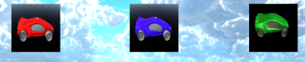

Figure Race cars in my game. The green car is locked by default.

**Race Cars**

**In the current version, there are three cars available for the players to choose from. By default, the player can choose two unlocked cars (red and blue textured cars) as they do not have any cash to spend on locked cars at the start of the game. As players complete more races and consequently earn more money, they can unlock the locked cars and play them. The game has a green locked car, and the interface has been set up such that the green car cannot be clicked if the player does not have enough money.**

**Game Modes**

**There are three game modes: race mode, score more and time mode. Every race starts with a countdown to alert the player that the race is about to begin.**

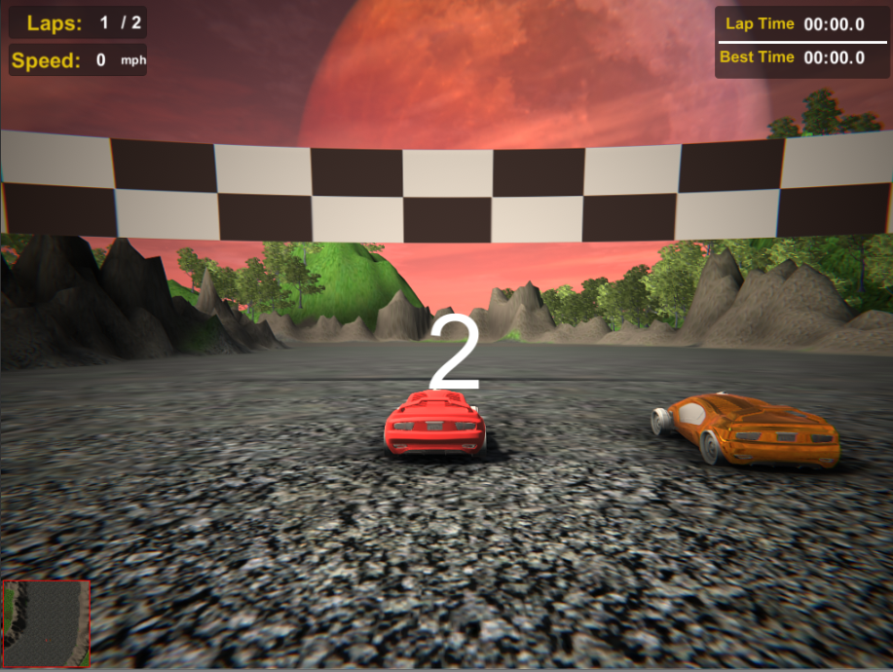

Figure Race countdown in Race Mode. There is also an AI car next to the player car.

**Race Mode**

**Race mode is the default race mode in Annapurna Racing. The mode features Player vs. AI race car competing for first place by completing two laps. The race mode keeps track of lap time and contains scripts that update the best lap time if players better their previous lap record.**

**Score Mode**

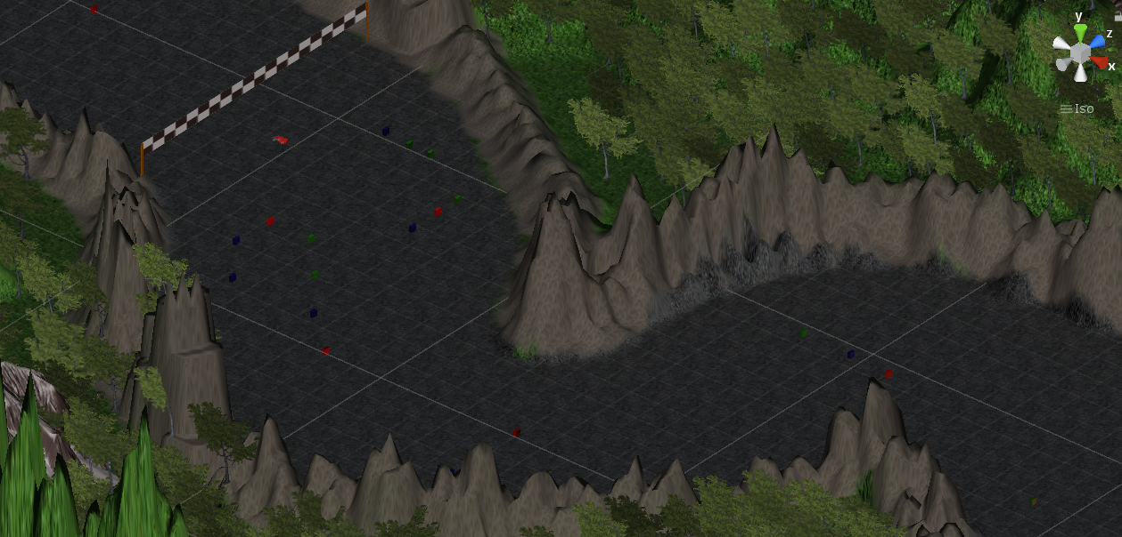

Figure The score mode contains several colored cubes scattered across the racetrack

**In score mode, players need to pass their car through the objects scattered around the racetrack that will earn them points. There are red, blue and green colored cuboids in the track and each of them earns different points for the racer. For example, passing through a green object will earn the racer 25 points, blue objects will earn 50 points, and red objects will earn 100 points. The player has two laps to complete going through those objects and earn as many points as possible. The game mode is intended to provide the user with a new feel to the racing game.**

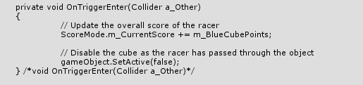

Figure Code snippet that handles updating of scores for the racer when they pass through a blue cube in score mode

**Time Mode**

**In time mode, players try to beat their previous best lap time record. Time mode is intended to provide more practice to new players.**

**Random Mode**

**In random mode, the script will randomly choose a car, a game mode, and the racing track to play the game. The script will randomize among three different cars, three different game modes and one racing track. The random mode serves to ease the process of playing the game as fast as possible.**

**Cash Reward Feature**

**Games need to continually evolve so that players do not lose interest in playing the same cars even after completing the races. Hence, players are rewarded $300 in cash after they complete a race. The cash can be earned by playing Default Race Mode and Score Mode.**

**The cash earned by the player can be used to unlock new cars or in the future, new tracks. In the current version of the game, players can unlock the green car which cost $400 to unlock**.

**Extra Game Features**

**Camera Modes**

Annapurna Racing features three camera modes that help players to race based on their preferences. The player can switch between these camera modes by pressing “**C**” on the keyboard. The different camera modes are as follows:

* Normal View:
  + The camera is attached a few feet behind the racer and is the default camera mode. Generally, people who have played racing games prefer this camera mode.

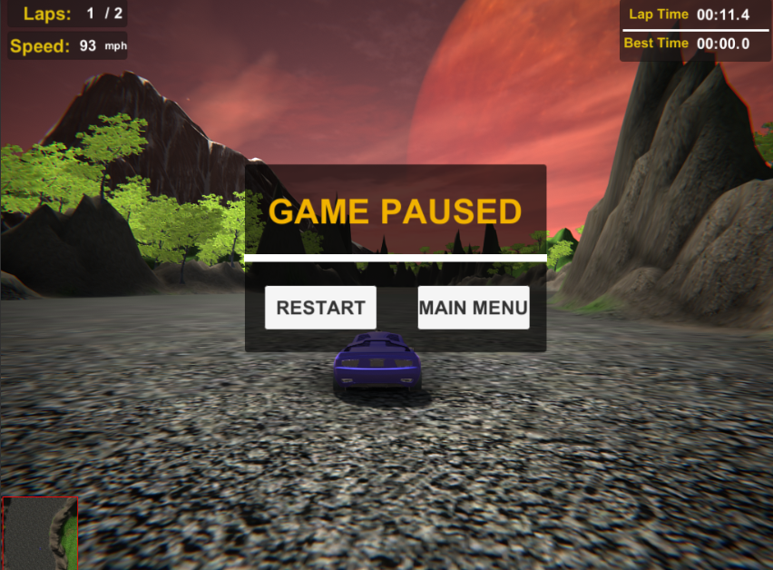

Figure The default camera mode

* Eagle Eye View:
  + The camera is situated higher than the normal view camera and covers more width. The camera mode is especially useful to keep tabs on enemy cars coming behind the player cars.

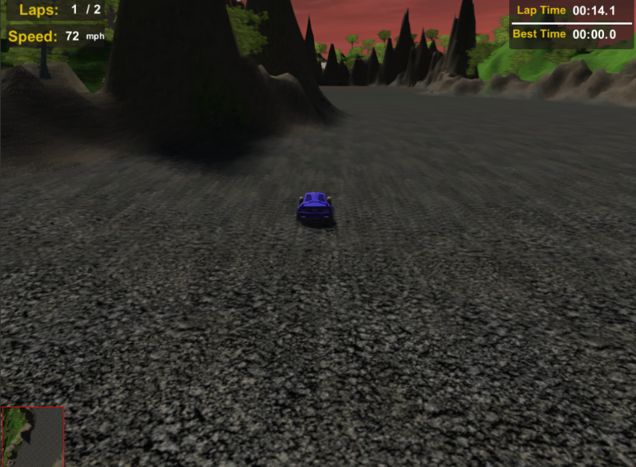

Figure The eagle eye camera mode

* Driver View:
  + The camera is situated a few feet in front of the player’s car. The camera mode gives racers the ultimate feeling of driving as in real life.

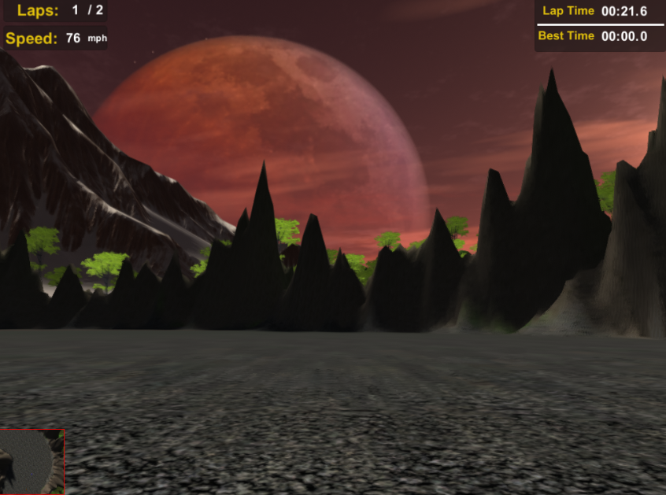

Figure The driver camera mode

**Pause/Continue/Restart Game**

The racers also have the option to pause the game during their race by pressing “**P**” or “**Esc**” keys on the keyboard. The game pause panel will be displayed when they want to pause the game. The lap time, car audio, car controls will all be disabled when the game is paused. Lap time can be paused by setting “**Time.deltaTime = 0**”. In Unity, Time.deltaTime refers to the time in seconds it took to complete the last frame. So, setting the null value will stop Unity’s time completely. Objects will not be able to move as the frames have been frozen.



Figure The Game Pause panel

Pressing “**P**” at even numbers will deactivate the game pause panel and resume the lap time. In Unity, Time.deltaTime will be set to 1 which is also the default value. The AI cars will continue as the car control script is enabled and continuing the game will give back controls to the player. Also, car audio scripts are enabled.

The game pause panel features two clickable buttons. “**Restart**” button will take the player to the Track and Car Selection menu and let the player choose the car, game mode and track again. On the other hand, the “**Main Menu**” button will take the player to the main menu where the player has the options to play the game, check game credits or play random game mode.

**Speedometer**

All the game modes contain a UI on the screen that retrieves the current speed of the car in mph from the Car Control script and displays in real time. I have also handled the negative speed of the car by capping the speed at 0 mph.

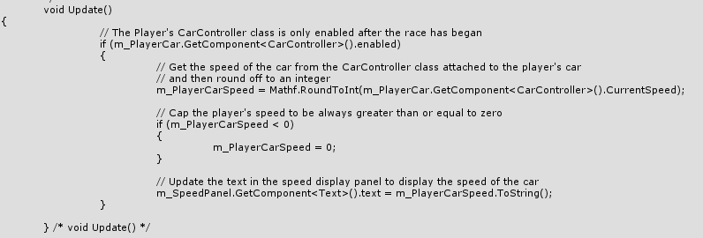

Figure Code snippet that handles displaying the speed of the car

**Minimap**

The game modes also contain a minimap which is placed at the bottom left corner of the game screen. The minimap shows the real-time position of the game car as the race car moves around the track. I achieved the feature by attaching a live texture object in the UI. The live texture renders the camera focused on the race car. The camera is placed at a considerable height above the race car.

**Skybox Rotation**

All the backgrounds in the game are skybox. “Skyboxes are rendered around the whole scene to give the impression of complex scenery at the horizon. Internally skyboxes are rendered after all opaque objects, and the **mesh** used to render them is either a box with six textures or a tessellated sphere” (*Skyboxes*). The skyboxes are rotated in the screen to create a beautiful view.

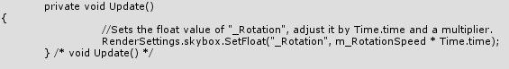

Figure Code snippet that handles the rotation of the skybox. The Update() function is called at every frame. Hence, we see the skybox moving in the background.

**Game Scenes**

**Splash Screen**

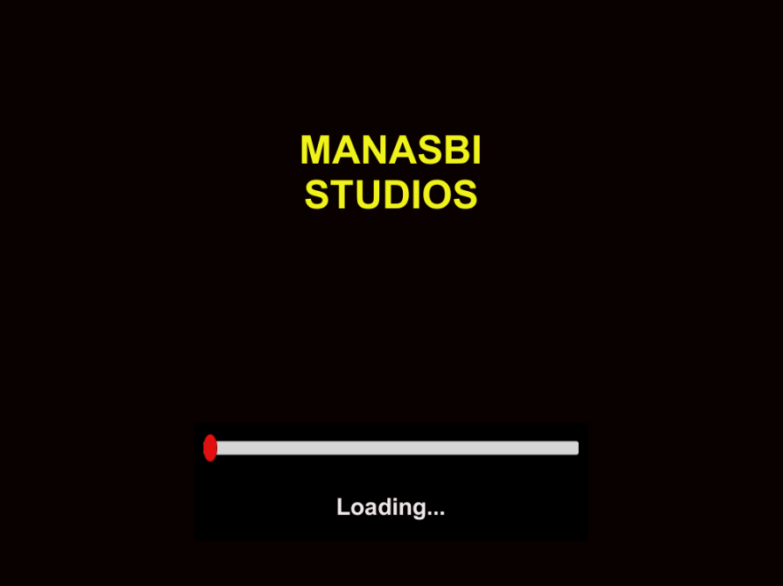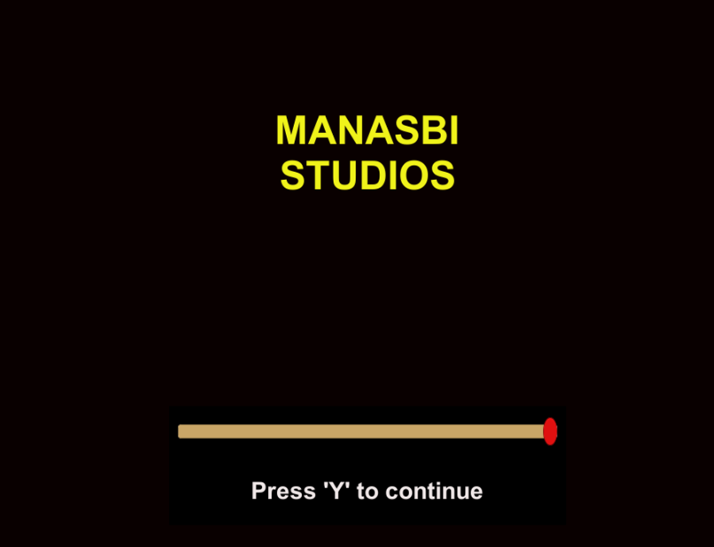

Figure The splash screen before loading bar initiates and after it completes

The first scene when a player starts the game. The splash screen comes after the “Made with Unity” logo which cannot be removed as I used the free version of Unity to make my game. The splash screen displays the game studio name (Manasbi Studios) and a progress bar.

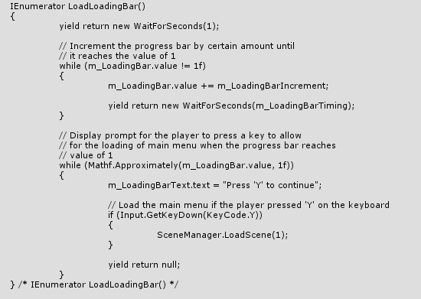

Figure Code snippet that handles the animation of the progress bar. After the progress bar reaches the value of 1, it will prompt the player to press a key.

The progress bar has slider attached to it and the slider increments with a certain amount before displaying a prompt for the player to click anywhere on the screen. Then, the player will be directed to the next scene, the Main Menu.

**Main Menu**

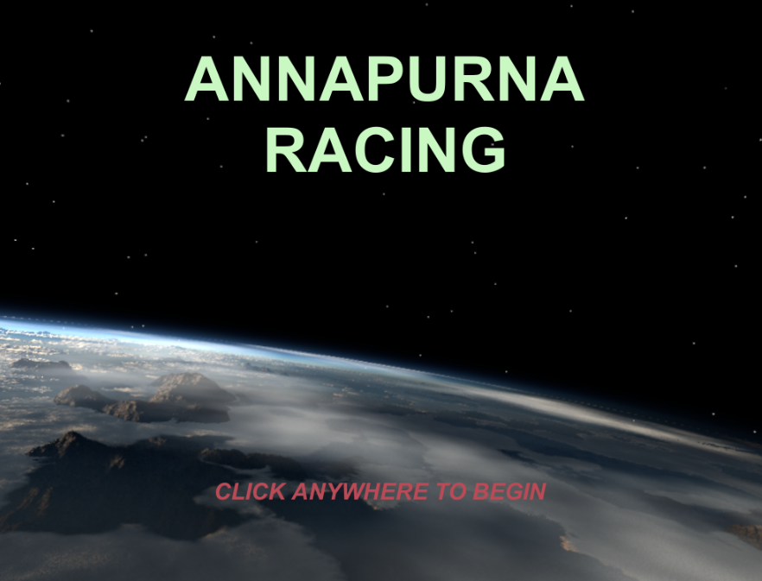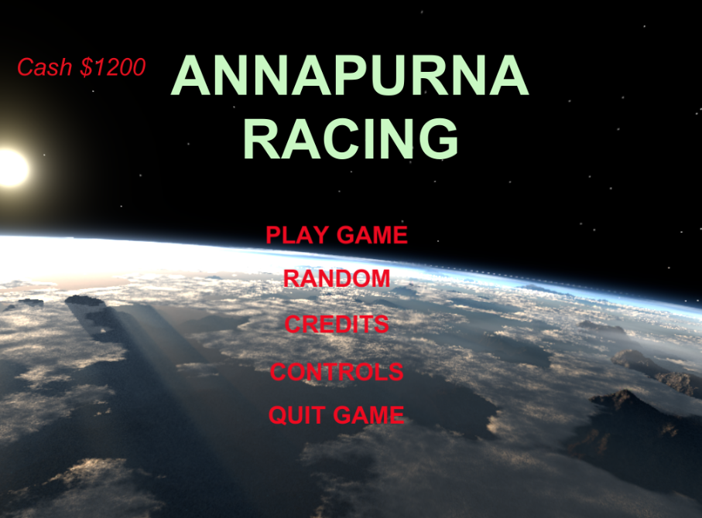

Figure The main menu screen before after the player clicks anywhere on the screen

The main menu initially displays the game name and then prompts the player to press “Y” to continue. Once pressed, the screen will load the main menu buttons. Players have the option to play the game, choose the random game mode, check game controls, see game credits and quit the game. Scripts are attached to these game buttons that will load the new scenes accordingly.

The player will also check the cash they have earned on the top left corner of the screen.

**Track and Car Selection Menu**

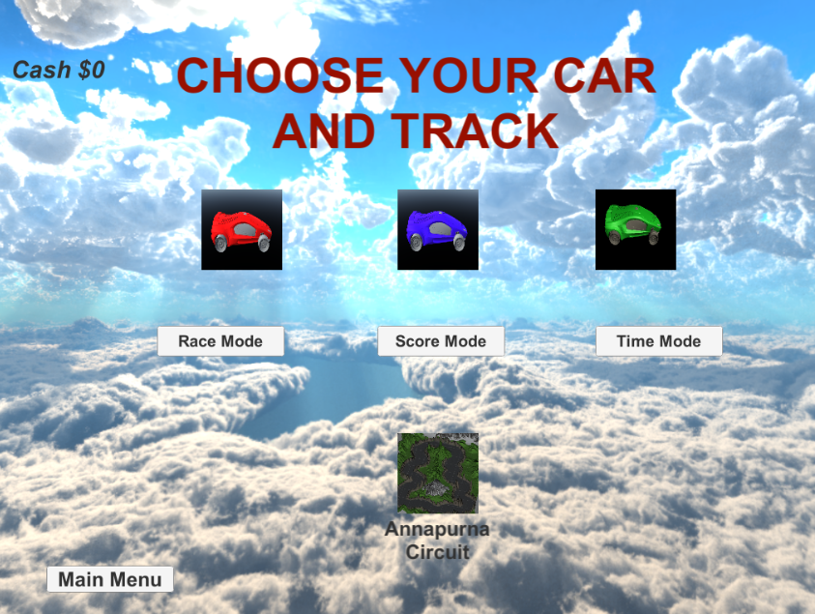

Figure Car, Game Mode, and Track Selection menu

The scene features different cars, game modes and tracks that the player can choose. There are three different cars, three different game modes, and one single racing track. The player is also able to keep track of the cash earned as the money is shown in the top left corner of the screen. Also, the player can go back to the main menu as there is a “Main Menu” button in the bottom left of the screen.

There are scripts attached to the buttons in the selections. The selections need to be made in chronological order for the player to play the game. Firstly, the player must choose between three cars. After the selection is made, the player can choose from among the game modes. Then, the track selection panel will be active and allow the player to choose the racing track and play the game.

In the same menu, the player cannot click on the locked green car when they start the game as they won’t have played any games to earn cash. If the players have enough cash, then they need to click on the green car twice to unlock it. This is because there is another game object masking the green car and which is non-interactable. Hence, the first click will deactivate the masked game object and expose the green car to player clicks.

**Game Controls**

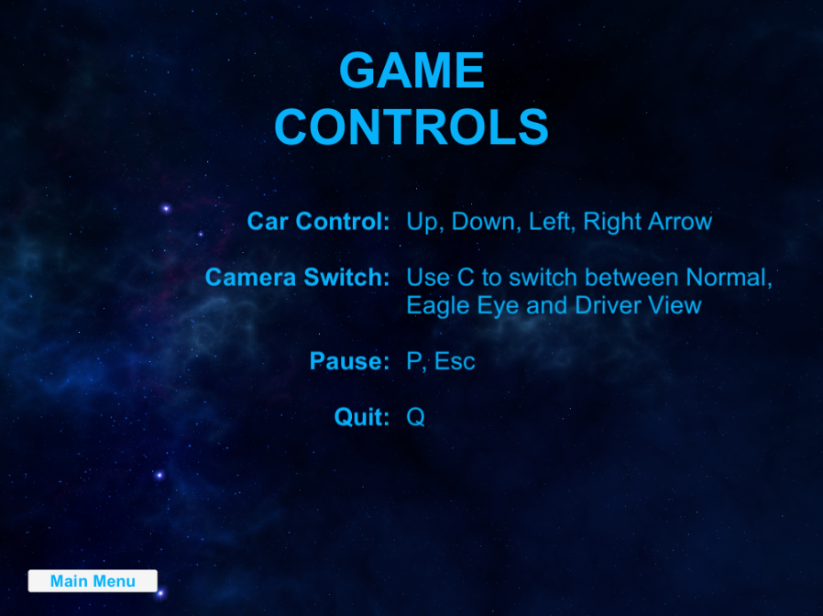

Figure The Game Controls scene

The scene contains information on using different keys to play the game. The race car control keys, pause key and camera switch keys allow the player to take control of the game.

**Game Credits**

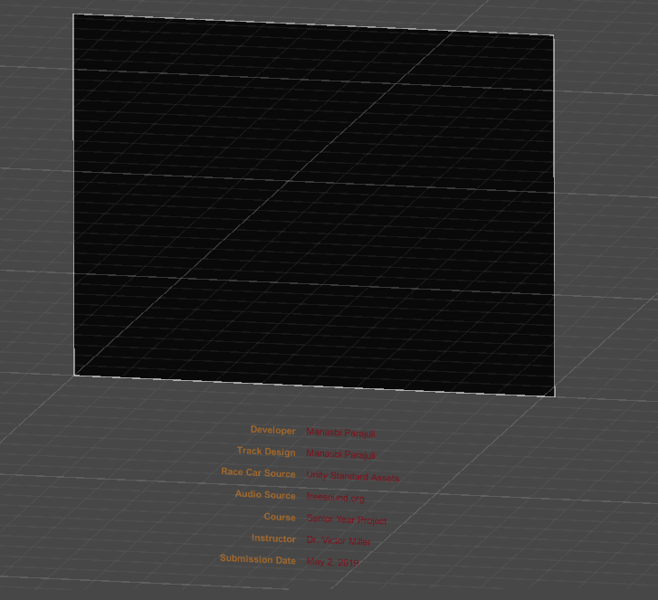

Figure The Game credits scene. Initially, the information is hidden below the screen. Then, using Unity's animation the information moves towards the center of the screen

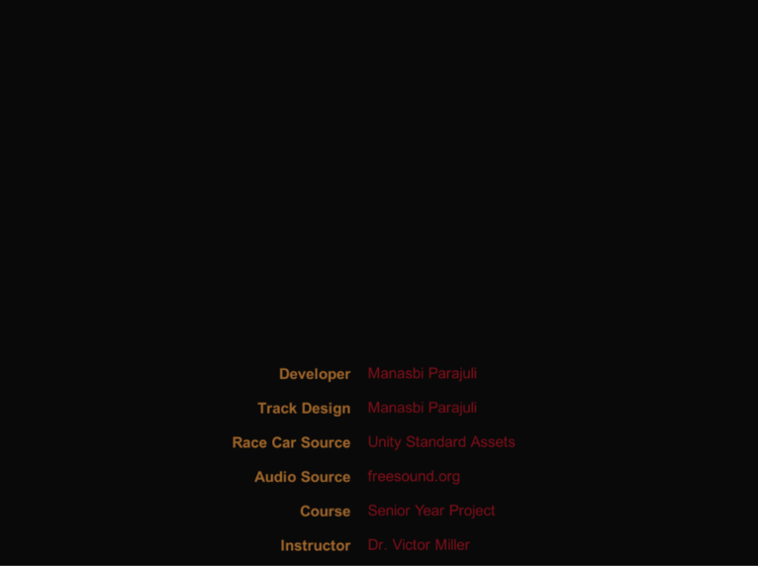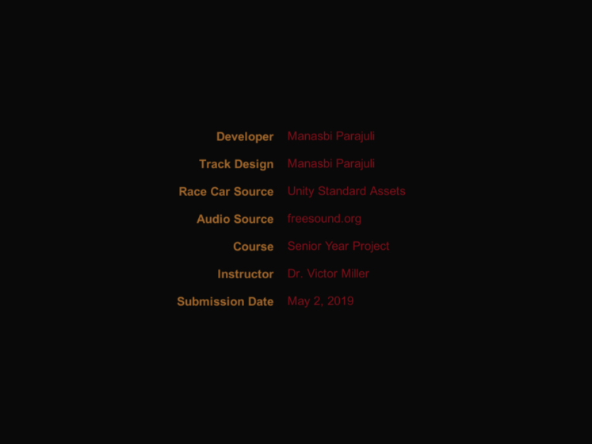

Figure The screen at the start and end of the animation.

The scene has animation attached to the information containing the game credits and resources used in the game. I used Unity’s animation to bring the game credits from outside the game background and hover over to the middle of the screen. The entire animation takes about nine seconds. After the animation is finished, the screen switches to display the main menu.

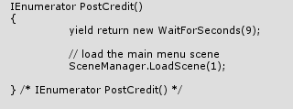

Figure Code snippet that waits for nine seconds to allow for the animation to finish and then load the main menu scene.

**Quit Game**

The scene closes the application window in which the game is run. Also, if the game is run in the Unity Editor, then the editor stops playing in the Game window.

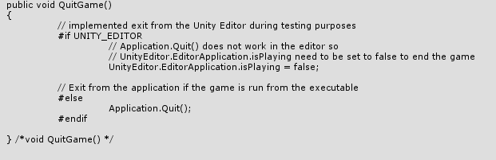

Figure Code snippet to handle quitting of the game either from the game editor or from the game application.

**Unity Design**

Unity Technologies has been at the forefront of game development. The company has very resourceful APIs which are well documented. The interface also allows for any beginners to get hold of the software quickly. Also, as I had prior experiences in developing 2D games in Unity, developing Annapurna Racing was worth a big challenge as I had never designed a 3D game before.

In designing the game, I had used many assets from the Unity Assets Store. Much tweaking had to be made to make the game playable. I had initially started with the design of my track and then proceeded to play around the car scripts. Once the car was up and running, I started to design the track with colliders on the banks of the track to prevent any cheating from the player. As the process continued, I focused more on the elements that made a racing game such as triggers to activate when the racer passed through the finishing line or midway through the track or keep track of the lap time and reflect the best lap record.

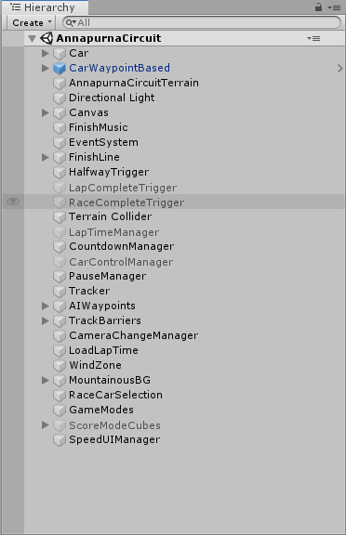

Figure The game objects in my Annapurna Racing Track scene. The greyed-out game objects are disabled at the start and get activated by various events in the game as dictated by scripts attached to them.

I also used scripts to play audio during the race or different music when the race ends or audios to signal the race countdown to alert the racer for the beginning of the race.

Unity has an easy to use GUI. By creating game objects throughout the scene and then attaching scripts to them, we can modify the behavior of the game objects to suit our project needs. That is one of the reasons why I do not have a fixed set of classes like Race class, Player class, Audio class and so on. In my Unity project window, I have placed many game objects that have scripts attached to them.

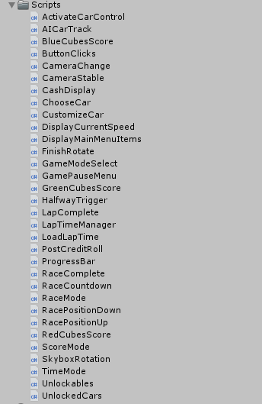

Figure A list of scripts in my racing game

I have used several scripts as noticeable in my Project hierarchy that serves only one function. The decoupling makes my public classes free from name pollution and adheres to the software design principles of autonomy. The autonomy is also significant for testing purposes as I do not want to spend too much time figuring out where in my code the flaws are. Hence, I did not need to tackle the game using OOP classes. Sure, the C# scripts in themselves are a public class, but they serve the sole purpose of manipulating the game objects.

**Functions and Variables Inside Scripts:**

In most of my scripts, there are two crucial functions: Start() and Update(). Start() function is called at the first frame and only once when the class is first called. The Update() function, on the other hand, is called on every frame update meaning that at every second of the race, the objects are manipulated continuously inside Update() function.

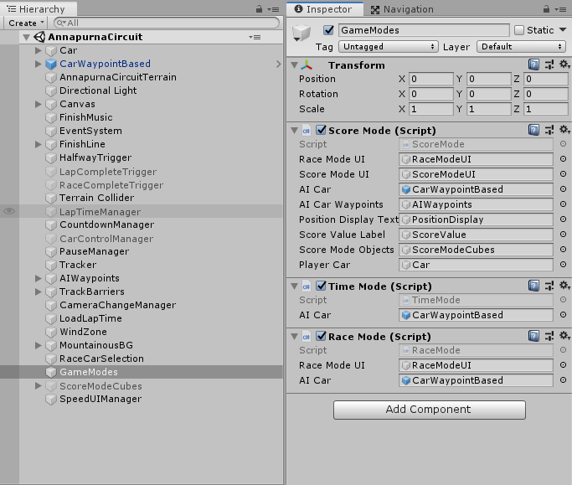

Figure The game object GameModes contains three scripts attached to it. In the scripts, all the variable names have been exposed in the Unity Editor using [SerializeField]. Then, the corresponding game objects are dragged and dropped into the variables.

The way Unity can modify game updates is that we expose the variables as public which will then be exposed in the Unity Editor window. Then, we can drag and drop the game objects that we are modifying using the script. To protect the public variable from being accessed by another class, Unity provides a keyword called “SerializeField” that we can put in front of the variables and this protects the variable from being corrupted by another public class. “SerializeField” will only expose the variable to the user in the Unity Editor and not to other classes. In some classes, I have used static variables as they need to be only one instance for these variables in the entire project.

**Player Preferences**

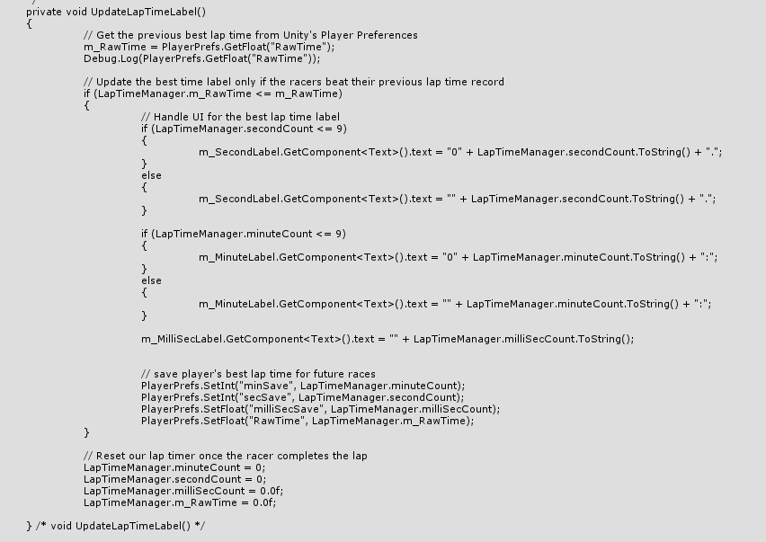

Figure Use of PlayerPrefs to keep track of lap time and save the values so that best lap time can be updated by another script

I have used Unity’s Player Preferences to save some of the game data required for the next start. For example, I do not want to lose the total cash earned by the racer when the player restarts the application. The player would waste the effort of completing the race and completely ruin the gaming experience. Keeping track of the cash earned will serve as an incentive for the player to play next time and fulfills one of the critical elements to game design principle: the motivation to earn more and unlock even more race cars or tracks.

Player Prefs stores and accesses player preferences between game sessions. They are stored as key-value pair in the same way as Hash Maps are used. Both keys and values are strings. For example, on Windows, “PlayerPrefs are stored in the registry under HKCU\Software\[company name]\[product name] key, where company and product names are the names set up in Project Settings” as compared to WebGL, where “PlayerPrefs are stored using the browser's IndexedDB API” (Unity Technologies *PlayerPrefs*).

My scripts have also used Player Preferences to keep track of the best lap time achieved by the players in their races. A separate script handles the lap time and then compares the value to the one saved in the Player Preferences. If the lap time is better, the script updates the new value in Player Preferences as well as the best lap time panel in the game UI. Now, when the player closes the application, then the best lap time will be retrieved from the particular directory where the PlayerPrefs was stored and shown in the screen for the user.

**Project Hierarchy**

When designing a large project, developers prefer to classify the files into different directories as the process eases the development process. We can know where our files in the directories will likely be. For example, all my game scripts are placed under Scripts directory while the audio files are under Audio directory. The other folders include Assets, Unity Standard Assets, Game Scenes, Prefabs, Graphics, and Animations. I have greatly benefitted from using the Project Hierarchy.

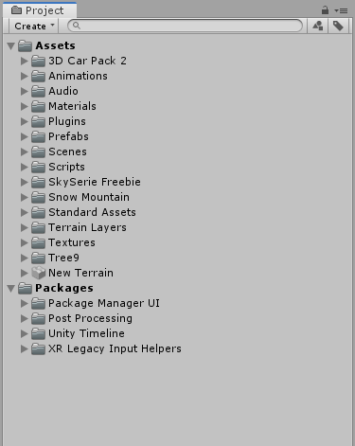

Figure Project Hierarchy as displayed in Unity Editor

**Test Plan and Test Results**

A software application cannot be built without the developer running into bugs. The racing game consisted of many bugs and I had to consistently use Debuggers to fix the bugs. I used Unity’s Play window to test the game. I can just click on the Play button and test it in real-time.

Like every programmer, I formed a habit to play the game as soon as I made some changes in my script or put a new game object in the project hierarchy. I tested my gameplay using the experiences I had either watching the racing games or playing the racing game titles. Hence, I knew what needed to be achieved in the process of fixing the bugs.

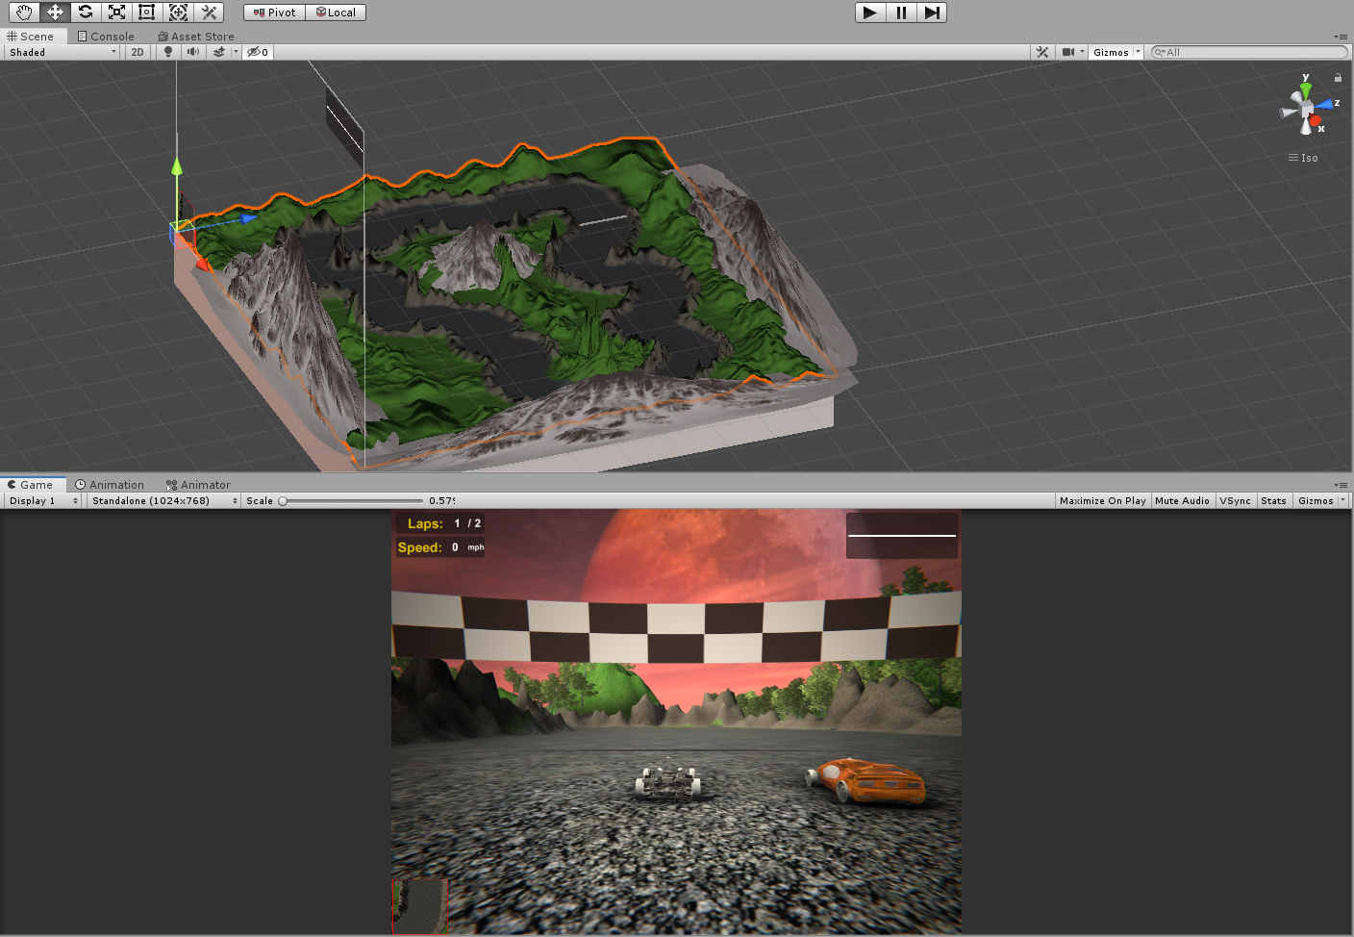

Figure The Unity Editor window. The scene tab is where I arrange game objects to create the game scenes. I test the game by clicking "Play" button and testing in "Game" window.

Sometimes, even after testing the game in Unity Editor window, running the application as executable window would produce inconsistent results. Hence, after adding numerous features, I would build the game and run the game as any new users would. Performing such actions would display some distorted UI and I had to fix UI accordingly. Unity has the concept of anchoring the UI elements to different positions in the screen and would work differently if the UI elements are nested under each other in the canvas. I would then fix the anchoring issue by decoupling the UI elements and changing the anchor position.

I also demoed my game to my friends and used their feedback to improve the gameplay. They reported about lapses in the game, bugs in lap time, and even camera system. I also got the idea of loading bars from my friends.

**Summary and Conclusions**

Annapurna Racing has been very dear to me. I had fun in making the game from the start. The idea of making a 3D racing game from a young age and understanding the game mechanics at the same time has been very appealing to me. During my journey, I have highly appreciated the efforts game developers put into making a great game because they strive to put together all aspects of making a great game.

On my Computer Science college career, I have had experiences with developing 2D games and Annapurna Racing was my first 3D game. I did not have any experience working with Terrain System in Unity and developing the track was a huge challenge for me. Also, all the games that I had worked on were small scale. As a single developer, I developed good habits in planning a large scale project and using different development tools to ease the process. I had used Unity, Visual Studio Enterprise, Git Hub, Debuggers and Profilers as part of my efforts to develop good software development practices.

Developers have a lot of roles in the game industry. Since I had to take care of AI, sound design, level design, user preferences, game UI, modifying game assets and animations, I had to research a lot into covering all the aspects of the game. The entire research process was exhausting but I enjoyed fully. I also had to analyze and implement the best current game practices. I had to fine-tune most of my parameters to achieve the best racing experience for the player.

I enjoyed the process of documenting my code base as per the course requirement. Adhering to a single style of documentation and remaining consistent throughout the project helped me to maintain discipline. Documenting code is also a great software engineering practice. I can look at the code three or ten years from now and understand the workflow of the project easily. I have prioritized explaining the function of the variable as clearly as possible and developed great practice in naming them appropriately.

Overall, the efforts put into developing Annapurna Racing has raised confidence in me to develop any large-scale projects. I developed good habits of using development tools, writing documentation and creating an efficient project hierarchy. Additionally, I have appreciated the idea of breaking down large scale programs into subprograms and tackling them. I also realized how crucial it is to understand the building blocks of a large-scale program and why it is important to make our building blocks foolproof. For example, in Annapurna Racing, I had to ensure that the design of the track is completed first before I can build other aspects of the racing game.

Hence, Annapurna Racing is one of my best achievements till date. I have grown considerably since the start of the semester and improved my software development skills to reach the maximum potential.

**Bibliography**

“Freesound.” *Freesound*, freesound.org/.

Jimenez, Eduardo. “The Pure Advantage: Advanced Racing Game AI.” *Gamasutra Article*, 3 Feb. 2009, [www.gamasutra.com/view/feature/3920/the_pure_advantage_advanced_.php](http://www.gamasutra.com/view/feature/3920/the_pure_advantage_advanced_.php).

McMillan, Luke. “A Rational Approach To Racing Game Track Design.” *Gamasutra*, www.gamasutra.com/view/feature/6477/a_rational_approach_to_racing_game_.php?print=1.

Technologies, Unity. “PlayerPrefs.” *Unity*, docs.unity3d.com/ScriptReference/PlayerPrefs.html. < <https://docs.unity3d.com/ScriptReference/PlayerPrefs.html>>.

Technologies, Unity. “Skybox.” *Unity*, docs.unity3d.com/Manual/class-Skybox.html.

< <https://docs.unity3d.com/Manual/class-Skybox.html>>.

Technologies, Unity. “Standard Assets.” *Asset Store*, assetstore.unity.com/packages/essentials/asset-packs/standard-assets-32351.

Vegas, Jimmy. “How To Make A Driving & Racing Game For FREE - Unity Tutorial - BEGINNER BASICS.” *YouTube*, YouTube, 15 Mar. 2017, www.youtube.com/watch?v=MQ5GJPlAGS4.

Zucconi, Alan. “Implementing a Loading Bar in Unity.” *Alan Zucconi*, 30 Mar. 2016, [www.alanzucconi.com/2016/03/30/loading-bar-in-unity/](http://www.alanzucconi.com/2016/03/30/loading-bar-in-unity/).